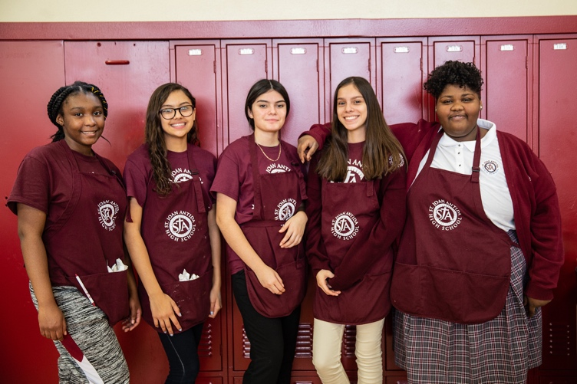
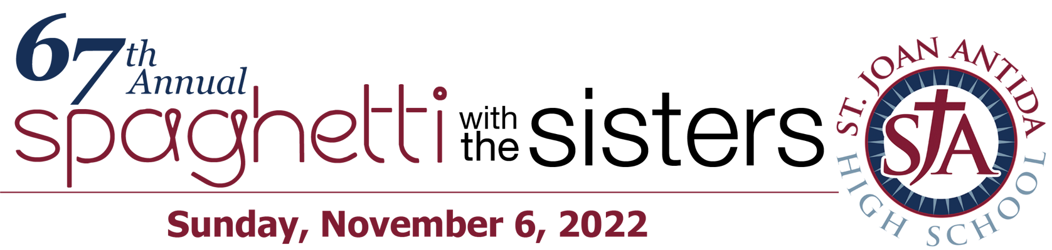
UNDERWRITING COMMITMENT FORM
*Please return by Friday, September 30, 2022*
Please select the area you wish to underwrite:
- MEATBALLS ($2,500)
- CARRYOUT ($1,500)
  - PRE-ORDERS ($1,000)
- NOODLE STATION ($750)
- CANNOLI ($500)
- SALAD/BREAD STATION ($500)
          - APPLY $ ________________ towards a portion of:
__________________________________________________

(PLEASE PRINT)

Organization Contact Name
Name as it should appear on event materials
Address
City, State, Zip
Phone Fax
Email Website

- Enclosed is my check made payable to: St. Joan Antida High School

- Please charge my payment to my Visa MC AmEx
Card Number
Expiration Date Security Code
Name on Card
Billing Address
City, State, Zip
St. Joan Antida High School (SJA) commits to providing the Sponsor with the benefits appropriate to the sponsorship level, as indicated on the event sponsorship form. SJA is a 501(c)(3) nonprofit organization (EIN #39-1570748). Donations are tax-deductible to the extent allowed by law.

St. Joan Antida High School I 1341 N. Cass St. Milwaukee, WI 53202 I 414-272-8423
SaintJoanAntida.org

